Ball Peen Hammer

Objective: The student is expected to understand and demonstrate the following operations.

- Practice various lathe operations

- Read work drawings

- Threads and classes of fits

- Assemble machined parts

- Observe the necessity of tolerances

- See how planning a job leads to “Pay Off”

- Tolerance of ±0.005” unless otherwise specified

Requirements:

- Study the drawings first

- Read the steps (Procedures)

- Ask questions

- Wear the proper PPE

- Begin your work

- Work carefully

Revision 1: 7/30/2019

Ball Peen Hammer
Die Cut
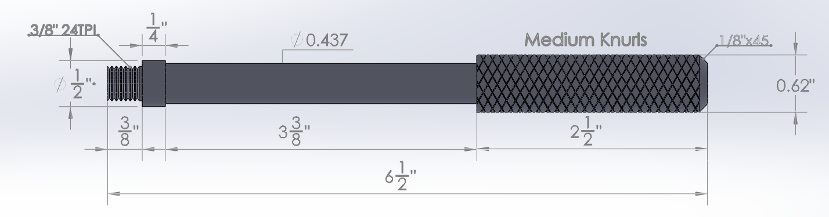

Handle Procedures:
- Cut and deburr material ¾" Hot Roll Round (HRR) -6 ¾ " long.
- Center, center drill and face both ends of stock.
- Take stock out 3 ½" and center with live center in center hole. Make sure to set-up the dial indicator as close to the jaws as possible.
- Turn down stock to .620 diameter.
- Bring stock in and center 1" out.
- Face off center hole cut out.
- Set-up compound rest at 45 degrees and cut angle 1/8" long.
- Turn stock around and center with aluminum pads 5 ½" out.
- Turn down the handle body to .500 diameter.
- Set-up the round nose tool and turn the body down to .437 diameter.
- Set-up the turning tool and turn down for the threads down to .372 diameter. (Tolerance of ±0.001”)
- Set-up die to cut 3/8" — 24 threads per inch (TPI).
- Set-up threading tool and cut out threads.
- Set-up lathe and knurling tool to form medium knurls.
- Knurl the 2 ½" long handle and clean.
- Deburr and polish all machined surfaces.

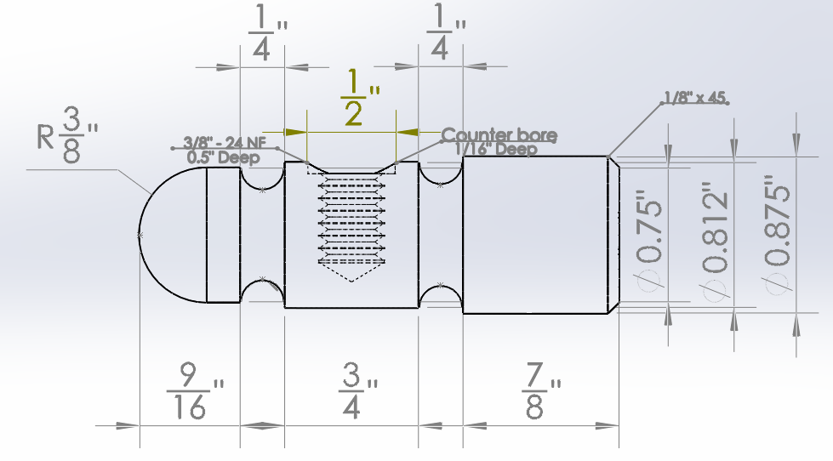
Head Procedures:
Lathe Operations:
- Cut and deburr material 1" H.R.R. — 4" long.
- Chuck up, center 1 ½" out and face one end only.
- Turn down head diameter to .875, 1" long.
- Set-up compound rest to 45 degrees and cut face chamfer 1/8" long.
- Turn around and chuck-up head with aluminum pads ¾" in the jaws.
- Turn down body diameter to .812.
- Turn down ball diameter to .750 as per drawing.
- Set-up the threading tool to cut the grove line as per drawing.
- Set-up the radius tool and turn down the grove on the .812 diameter down to .700.
- Turn down the grove on the .750 diameter down to .600.
- Turn the ball radius by using a flat file at a 45° angle to produce the desired shape. (Ask lab assistant for assistance in this step)

Milling Operations:
- Set-up the parallel bars on the milling vise.
- Set-up soft caps on the vise jaws and set-up hammer head into the vise jaws.
- Set-up the edge finder and locate center of hole on head.
- Set-up the center drill and drill center hole.
- Set-up the Q drill bit in the collet and drill tap hole ½" deep.
- Set-up the ½" end mill and cut counter bore .1 deep.
- Tap the hole with the 3/8"-24 TPI taper tap and then with the bottoming tap.
- Clean out tapped hole and check thread fit with the ball peen hammer handle.
- Set-up on lathe and deburr polish.

